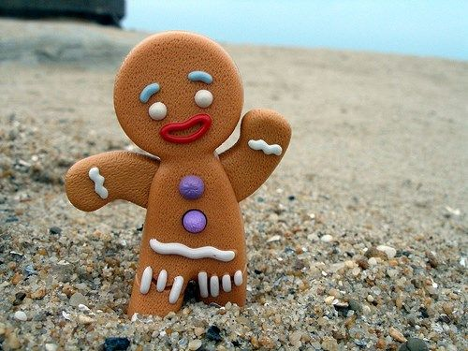
https://www.youtube.com/watch?v=dPECRgj122Q

The Gingerbread Man

An old woman lives here. An old woman and an old man. They don’t have any children. The old woman’s in the kitchen. She’s making something. It’s a gingerbread man.
He has a head. He has arms and legs. He has two eyes, a nose, and a mouth. The old woman is happy. ‘You’re a little boy,’ she says. ‘My little boy!’
‘In you go’ says the old woman. But soon the old woman hears a little voice. It’s coming from the oven. ‘Open the door!’ says the voice. ‘I want to come out!’
The old woman opens the oven door. And the gingerbread man jumps out.
‘Oh!’ says the old woman. ‘Stop!’ says the old woman. ‘Come here!’ But the gingerbread man doesn’t stop. He runs across the kitchen and out of the door.
‘Stop!’ shout the old woman and the old man. ‘Come here!’
But the gingerbread man doesn’t stop. He runs faster and he shouts: ‘Run, run! You can run. Yes, you can! But you can’t catch me. I’m the gingerbread man.’
The gingerbread man runs and runs. Soon he sees a cow.
‘Stop!’ says the cow. ‘Come here! I want to eat you.’
But the gingerbread man doesn’t stop. He runs faster. And now the cow runs after him.
‘I can run away from an old woman,’ says the gingerbread man. ‘I can run away from an old man. So I can run away from a cow!’
They all run after him. And the gingerbread man shouts: ‘Run, run! You can run. Yes, you can! But you can’t catch me. I’m the gingerbread man!’
The little gingerbread man runs and runs. Soon he sees a horse.
‘Stop!’ says the horse. ‘Come here! I want to eat you.’
But the gingerbread man doesn’t stop. He runs faster. And now the horse runs after him.
‘I can run away from an old woman,’ says the gingerbread man. ‘I can run away from an old man and a cow. So I can run away from a horse. Yes, I can! You can’t catch me. I’m the gingerbread man.’
The gingerbread man runs and runs. ‘They can’t catch me!’ he says. ‘Nobody can catch me.’
Just then he sees a fox. ‘Stop!’ says the fox. ‘Come here!’
But the gingerbread man doesn’t stop. He runs faster. And now the fox runs after him.
‘I can run away from an old woman,’ says the gingerbread man. ‘I can run away from an old man. I can run away from a cow and a horse. I can run away from a fox!’
They all run after him and he shouts: ‘Run, run! You can run. Yes, you can! But you can’t catch me. I’m the gingerbread man!’
‘Stop!’ says the fox. ‘I don’t want to eat you. I want to talk to you. I want to be friends with you!’
But the gingerbread man doesn’t stop. He runs faster. And now the fox runs faster too.
The gingerbread man runs and runs. Soon he sees a river.
‘Oh no!’ he cries. ‘A river! I can’t swim!’
‘Listen,’ says the fox. ‘I can help you. I can swim across and you can sit on my tail.’
So the gingerbread man sits on the fox’s tail. And the fox begins to swim.
But soon the fox says, ‘Listen! You are too big for my tail. Sit on my back.’
So the gingerbread man sits on the fox’s back. But soon the fox says, ‘Listen! You are too big for my back. Sit on my nose.’ So the gingerbread man sits on the fox’s nose.
The fox swims across the river and jumps out. The fox throws the gingerbread man up. Up! Up! Up!
Then he opens his mouth and …catches him.
‘Help!’ he says. ‘My legs! My legs!
‘Help!’ he says. ‘My arms! My arms!
Then the fox eats the gingerbread man’s head. Now the gingerbread man doesn’t say anything.
And that is the end. Yes, that is the end of the gingerbread man.

Source: The Gingerbread Man. Classic Tales. Level 2. Retold by Sue Arengo. Oxford University Press

RZECZOWNIKI | CZASOWNIKI | PRZYMIOTNIKI
arms – ręce  back – plecy, grzbiet  eyes – oczy  legs – nogi  mouth – usta, buzia  cow – krowa  fox – lis  horse – koń  tail – ogon  oven – piekarnik  voice – głos  gingerbread – piernik | catch – złapać  hear – słyszeć  jump – skakać  throw – rzucać  run away – uciekać | faster – szybciej

