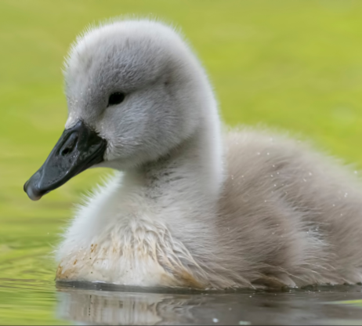
https://www.youtube.com/watch?v=o3w32LO7hKs

The Ugly Ducking

It is summer. A duck sits on her eggs. She sits and waits. She waits and waits. At last the eggs open.
‘At last!’ says the duck. ‘My little ducklings!’
But one egg does not open.
‘Mm,’ says her friend. ‘That egg is strange. Leave it.‘
‘Leave my egg?’ says Mother Duck. ‘No I can’t leave it.’ She sits down again and she waits. At last the egg opens.
‘Oh!’ says Mother Duck to her friend. ‘You’re right. He is strange. What an ugly duckling!’
But the ugly duckling can swim. He can swim very well. And Mother Duck is happy.
‘Come on ducklings!’ she says. ‘Let’s go to the farm! I want all my friends to see you.’
‘Hello, everyone,’ she calls. ‘Look at my little ducklings! This is my family,’ says Mother Duck.
‘Very nice. Very nice,’ say the ducks. ‘But that duckling is very big. He’s ugly!’
‘He’s strange,” they say. ‘He’s an ugly duckling.’
One of the ducks pecks him. Every day the farm girl comes. Every day she kicks him. ‘Go away, you ugly duckling!’ she says.
So one day the ugly duckling runs away. He runs away from the farm. ‘Go! Yes, go!’ say his brothers and sisters. ‘You’re strange! You’re ugly!’
It’s colder now. The ugly duckling is bigger.
One day, two geese see him. ‘Mm, you’re strange!’ they say. ‘You’re very ugly,’ they say. ‘But you’re interesting. Do you want to fly with us?’
But suddenly there is a bang. Bang! Bang! Bang! And the geese are dead. There are some men. Men with guns and dogs. The ugly duckling is afraid. A big dog comes. He sees the ugly duckling. And he looks at him. Then the dog swims away.
‘I am ugly,’ says the ugly duckling. ‘So, he doesn’t want to eat me.’
The ugly duckling runs away. He comes to an old hut and he goes in. In the hut there is a woman, a cat, and a hen. The woman is old and she can’t see.
‘What’s this?’ she says. ‘A duck? Ah! You can give me some eggs.’
‘Come on,’ says the cat. ‘Where are your eggs?’
‘I haven’t got any,’ says the ugly duckling.
‘Then go!’ says the hen. The ugly duckling goes away. It is winter now. And it is very cold.
One evening the ugly duckling sees something wonderful and strange. Three swans! Three big, beautiful swans.
‘Oh,’ he cries. ‘What beautiful birds! Big, beautiful and free.’
He calls to them. ‘Who are you? Take me with you.’ But they do not hear him.
It is winter now. It is cold. There is ice on the water. So the ugly duckling can’t swim. A man sees him. He breaks the ice with his shoe.
‘Poor bird!’ he says. ‘Come home with me.’
The man’s children want to play. ‘Come here!’ They say. But the ugly duckling runs away. He falls into the milk. The children laugh. ‘Come here!’ they say. Then he falls into the butter. Oh dear! What a mess!
Then he falls into the flour. ‘Get out!’ cries the man’s wife. ‘Get out of my house!’
The ugly duckling runs. Suddenly he starts to fly. The door is open. He flies up into the sky. He can fly! He can fly! ‘I can fly!’ says the ugly duckling. And now the sun comes out. It is spring. Then he sees a garden. A garden with a river. ‘What a beautiful garden!’ he says. And he flies down.
He sees something. He sees the swans. He sees the three swans. ‘Oh! They are beautiful!’ he says. ‘I must speak to them.’ But he is afraid. He looks down at the water and he sees his face. He is not an ugly duckling any more. He is a beautiful swan too. It’s true. It’s true! He’s not a duckling. He’s not a duck. He’s a swan. He’s a swan too.
Some children run down to the river.
‘Look Mother!’ they say. ‘A new swan! Look! Oh, look. Look at the new swan.’
‘Yes,’ she says. ‘Isn’t he beautiful!’
Source: The Ugly Duckling. Classic Tales. Level 2. Retold by Sue Arengo. Oxford University Press

RZECZOWNIKI | CZASOWNIKI | PRZYMIOTNIKI
birds – ptaki  duck – kaczka  duckling – kaczątko  goose – gęś  geese – gęsi  face – twarz  gun – karabin  hen – kura  ice – lód  river – rzeka  swan – łabędź  spring – wiosna  winter – zima | fly – latać  kick – kopać  laugh – śmiać się  peck – dziobać  swim – pływać | cold – zimny  dead – martwy  ugly – brzydki

