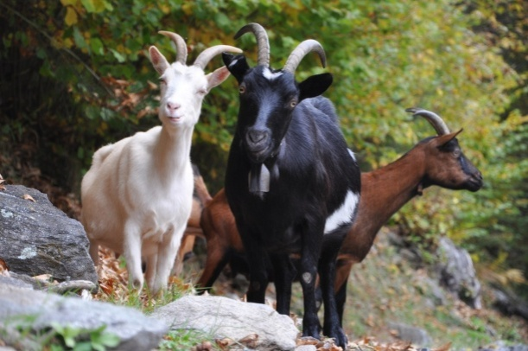
https://www.youtube.com/watch?v=_qKjoss2yvU

Three Billy-Goats

There are three goats. There’s a little goat. There’s a big goat. And there’s a very big goat.
The three goats like grass.
‘I’m hungry!’ says the very big black goat.
‘I’m very hungry!’ says the big red goat.
The three goats see a river. They see green, green grass.
‘Look!’ says the little goat. ‘Look at the grass.’
The three goats see a bridge. But there’s a troll under the bridge. He’s a bad troll.
‘This is my bridge!’ says the troll.
The three goats see the troll.
‘Look’ says the big red goat. ‘There’s a troll!’
The three goats are very hungry. They want the grass. They want the green, green grass.
The little goat goes on to the bridge. ‘Tip! Tap!’ go his feet.
The troll hears the little goat.
‘Who’s on the bridge? he says.
‘It’s me,’ says the little goat. ‘I want to eat the grass.’
The troll is hungry. ‘Come here!’ he says. ‘I want to eat you.’
‘Please don’t eat me!’ says the little goat. ‘I’m little. Wait for the next goat. He’s big.’
The troll listens. The troll thinks. ‘OK,’ says the troll.
And the little goat goes over the bridge.
The big goat goes on to the bridge. ‘Tip! Tap!’ go his feet.
The troll hears the big goat.
‘Who’s on my bridge? he says.
‘It’s me,’ says the big goat. ‘I want to eat the grass.’
The troll is hungry. ‘Come here!’ he says. ‘I want to eat you.’
‘Please don’t eat me!’ says the big goat. ‘Wait for the next goat. He’s very big.’
The troll listens. The troll thinks. ‘OK,’ says the troll.
And the big goat goes over the bridge.
The very big goat goes on to the bridge. ‘Tip! Tap!’ go his feet.
The troll hears the very big goat.
‘Who’s on my bridge? he says.
‘It’s me,’ says the very big goat. ‘I’m hungry!’ says the very big goat. ‘I want to eat the grass.’
But the troll’s hungry. ‘Come here!’ he says. ‘I want to eat you.’
‘OK. Here I come!’ says the very big goat. He runs at the troll.
‘Tip! Tap! Tip! Tap! go his feet. The very big goat runs at the troll. He hits him.
Up goes the troll. Up goes the bad troll. Up, up, up. ‘Help!’ he says.
Down comes the troll. Down comes the bad troll. Down, down, down.
‘Help!’ he says. And the very big goat goes over the bridge.
The bad troll goes away. He doesn’t come back.
‘Goodbye, troll!’ the goats say.
The three goats eat grass. They eat the green, green grass. They’re happy.
RZECZOWNIKI | CZASOWNIKI | PRZYMIOTNIKI | PRZYIMKI
bridge – most  feet – stopy, nogi  goat – kozioł  grass – trawa  river – rzeka | come back – wracać  eat – jeść  listen – słuchać  think – myśleć  wait – czekać | big – duży  happy – szczęśliwy  hungry – głodny | up – w górę  down – w dół
Source: Three Billy-Goats. Classic Tales. Level 1. Retold by Sue Arengo. Oxford University Press

